Activity Wording and images:

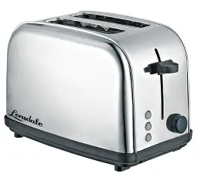

**The Toaster Chronicles: A Heated Tale**

Few kitchen gadgets inspire loyalty like the humble toaster. This unsung hero turns plain bread into golden perfection, crunching away our morning blues one slice at a time. From sleek modern designs to the battle-scarred veterans covered in crumbs, every toaster has a story. Some have braved bagels too thick for their slots, others have survived suspiciously long power outages. And let’s not forget the occasional rebellion—a stubborn slice that refuses to pop! Yet, despite their quirks, toasters remain steadfast, filling our kitchens with the comforting scent of warmth and nostalgia. Toast lovers, raise your bread in salute!



**The Art of Procrastination: Why We Put Things Off (and How to Stop)**

Ever found yourself deep in a Wikipedia rabbit hole instead of tackling your to-do list? You’re not alone. Procrastination isn’t just laziness—it’s often about fear of failure, perfectionism, or simply feeling overwhelmed.

But don’t worry, there’s hope! Breaking tasks into smaller steps, setting a timer for short bursts of work, and eliminating distractions can make a world of difference. Plus, rewarding yourself for progress (hello, snack breaks!) helps keep motivation high. So, next time you feel the urge to scroll aimlessly, take one small step toward your goal—you've got this!